Project Proposal Writing
 | Day |  |  | Month |  |  | Year
DATE | 0 | 4 | – | 0 | 1 | – | 2 | 0 | 2 | 1

Write down the brief project topic, the title should not be confusing.
PROJECT TITLE: | Face Recognition & Attendance
KEY WORDS: | FAJ Attendance
DOMAIN OF THE PROJECT: | Java Desktop Application
SUPERVISOR’S NAME: | Teerath Das (Dr.)

STUDENT INFORMATION
Sr. | Student ID | Name | Email | Mobile
1. | FA19-BSSE-0014 | Muhammad Fahad | FA19BSSE0014@maju.edu.pk | 03452849128
2. | FA19-BSSE-0063 | Ahmed Amin | FA19BSSE0063@maju.edu.pk | 03218224884
3.

PROBLEM STATEMENT
Face recognition-based attendance system is a process of recognizing the students face for taking attendance by using face biometrics based on high - definition monitor video and other information technology. It helps in conversion of the frames of the video into images so that the face of the student can be easily recognized for their attendance so that the attendance database can be easily reflected automatically
EXECUTIVE SUMMARY
Face recognition-based attendance system (FARA) is a process to automatically estimate the presence or the absence of the student in the classroom by using face recognition technology. It is also possible to recognize whether the student is sleeping or awake during the lecture and it can be implemented in the exam sessions to ensure the presence of the student. The presence of the students can be determined by capturing their faces on to a high-definition monitor video streaming service, so it becomes highly reliable for the machine to understand the presence of all the students in the classroom. The two common Human Face Recognition techniques are,

- Feature-based approach.
- Brightness-based approach.

The Feature-based approach also known as local face recognition system, used in pointing the key features of the face like eyes, ears, nose, mouth, edges, etc., whereas the brightness-based approach also termed as the global face recognition system, used in recognizing all the parts of the image.

INTRODUCTION
The technology aims in imparting a tremendous knowledge oriented technical innovations these days. Deep Learning is one among the interesting domain that enables the machine to train itself by providing some datasets as input and provides an appropriate output during testing by applying different learning algorithms. Nowadays Attendance is considered as an important factor for both the student as well as the teacher of an educational organization. With the advancement of the deep learning technology the machine automatically detects the attendance performance of the students and maintains a record of those collected data. In general, the attendance system of the student can be maintained in two different forms namely,
- Manual Attendance System (MAS)
- Automated Attendance System (AAS).
Manual Student Attendance Management system is a process where a teacher concerned with the particular subject need to call the students name and mark the attendance manually. Manual attendance may be considered as a time-consuming process or sometimes it happens for the teacher to miss someone or students may answer multiple times on the absence of their friends. So, the problem arises when we think about the traditional process of taking attendance in the classroom. To solve all these issues we go with Face recognition-based attendance system (FARA).

COMPETITORS/COMPETITIVE ANALYSIS
- Free Face Attendance App & Software By Gigasource
- Free Fareclock Face Attendance App
- Free Track Attendance by Attendlab
- Free Clockgogo Face Attendance App
- Free Jibble Face Attendance
- Free Mobile Attendance App by Railer
- Mobile Attendance App
- Free XmartClock Face Attendance

OBJECTIVES
The objective of this project is to develop face recognition based automated student
Attendance system. Expected achievements in order to fulfil the objectives are:
- To detect the face segment from the video frame.
- To extract the useful features from the face detected.
- To classify the features in order to recognize the face detected.
- To record the attendance of the identified student.

MOTIVATION
Because It’s a Smart Computer Vision Application with various functionalities. I have tried to put as many Machine Learning tools as possible into one single Application for greater productivity.

FEATURES OF PROJECT
- Auto Attendance system Using Face Recognition techniques.
- Face Trainer
- Motion Detection

Classification involves the process of identification of face. Distance classifier finds the distance between the test image and train image based on the extracted features. The smaller the distance between the input feature points and the trained feature points, the higher the similarity of the test image and training image

ARCHITECTURAL DESIGN
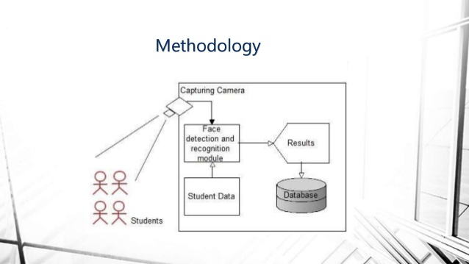
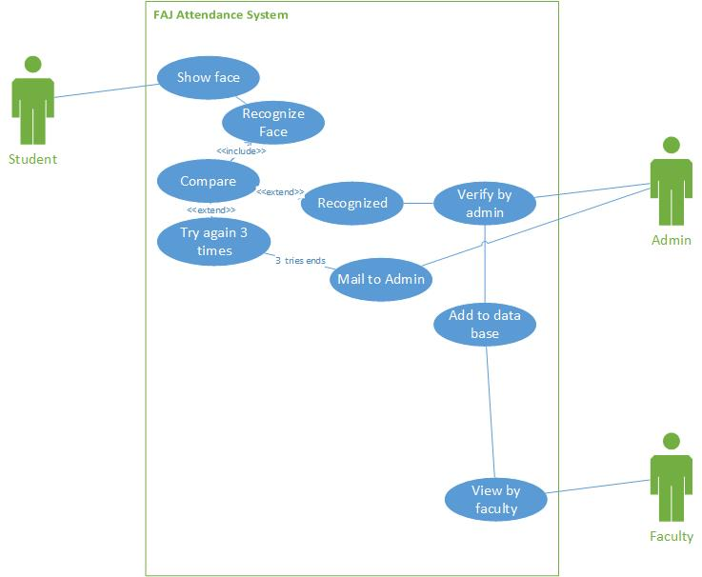

IMPLEMENTATION TOOLS AND TECHNIQUES
- Core Java
- JavaCV (wrapper of Opencv)
- JavaFX
- MySQL
- Tesseract OCR Framework

PROJECT PLAN
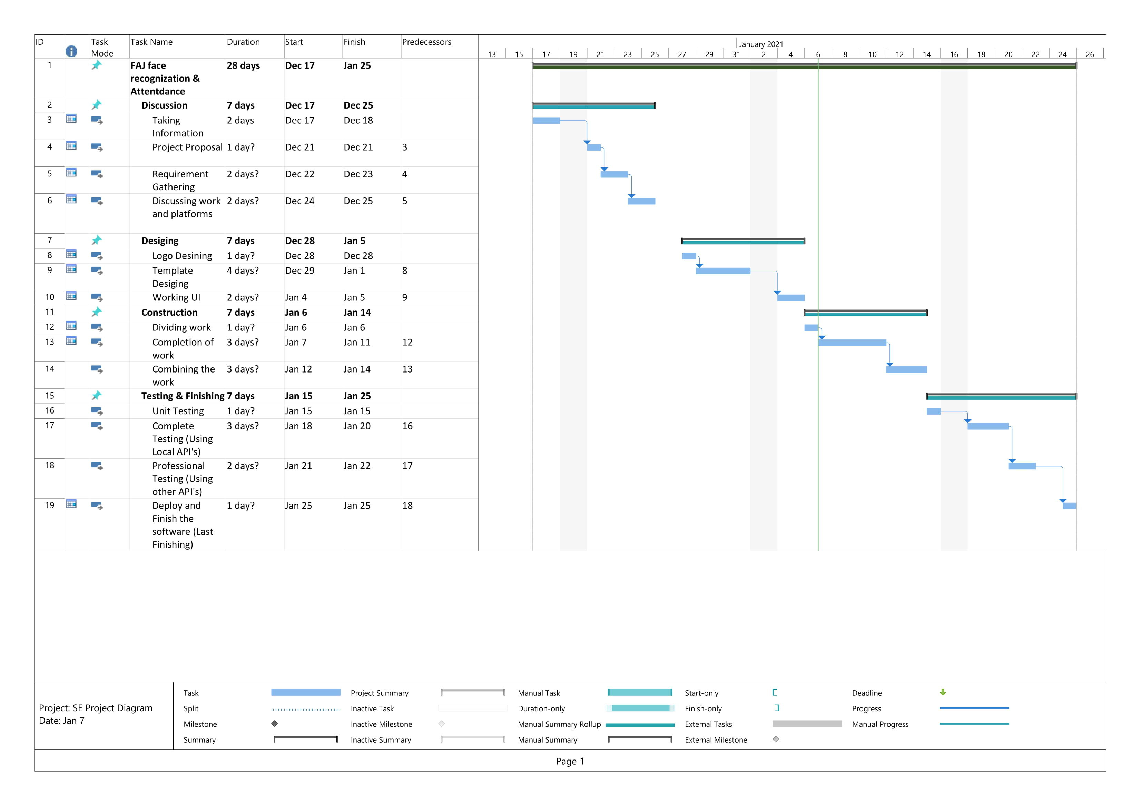

REFERENCES
Give references to the resources you have consulted in finalizing your project topic.
- https://www.youtube.com/watch?v=6UnBZFvY8HE
- https://github.com/TanyaDinesh00/FaceRecognitionAttendance
- http://www.ir.juit.ac.in:8080/jspui/bitstream/123456789/17139/1/SP13216_Mayank%20Sharma_141336_Piyush%20Thakur141339_CSE_2018.pdf
- https://www.researchgate.net/publication/337590875_Face_Recognition_based_smart_attendance_system_using_IOT
- http://eprints.utar.edu.my/2832/1/EE-2018-1303261-1.pdf

